Оптический трансивер BZ-SFP-LX-10
Основные характеристики:
- Оптический трансивер SFP, скорость передачи данных 1.25Gbps;
- Лазер FP, длина волны 1310nm, расстояние передачи – 10 км;
- Совместимость с SFP MSA и SFF-8472, разъем duplex LC;
- Соответствие SONET OC-24-LR-1;
- Соответствие RoHS;
- +3.3V single power supply;
- Диапазон рабочих температур: 0°C ~ +70°C,
-20°C +85°C (индустриальный);
- Цифровой диагностический мониторинг:
Внутренняя калибровка или внешняя калибровка.

Блок-схема модуля 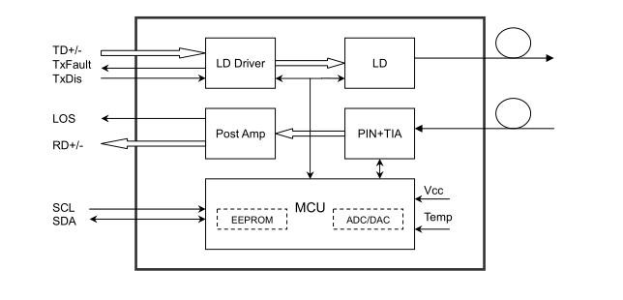
Распиновка блока разъемов на главной плате
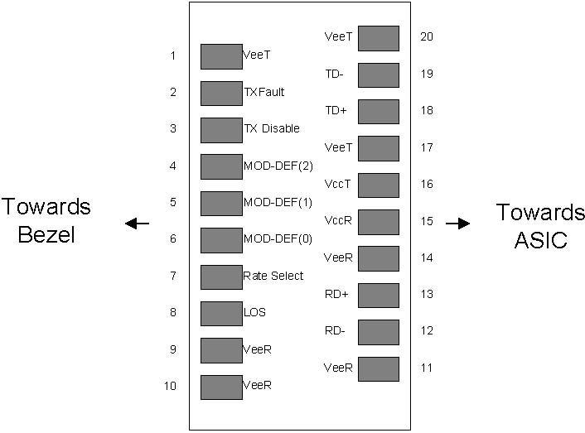
Абсолютные максимальные рейтинги
Parameter | Symbol | Min | Typ | Max | Unit | Ref.
Maximum Supply Voltage | Vcc | -0.5 |  | 4.7 | V
Storage Temperature | TS | -40 |  | 85 | °C
Case Operating Temperature | TOP | 0 |  | 70 | °C

Оптические характеристики
Parameter | Symbol | Min | Typ | Max | Unit | Ref.
Transmitter
Output Opt. Pwr (End of Life) | POUT | -9.0 |  | -3.0 | dBm | 1
Optical Wavelength | λ | 1270 | 1310 | 1360 | nm
Wavelength Temperature Dependence |  |  | 0.08 | 0.125 | nm/°C
Spectral Width (-20dB) | σ |  |  | 3.0 | nm
Optical Extinction Ratio | ER | 10 |  |  | dB
Sidemode Suppression ratio | SSRmin | 30 |  |  | dB
Optical Rise/Fall Time | tr/ tf |  | 100 | 160 | ps
RIN | RIN |  |  | -120 | dB/Hz
Transmitter Jitter (peak to peak) |  |  |  | 100 | ps
Receiver
Average Rx Sensitivity @ Gigabit Ethernet | RSENS3 |  |  | -24.0 | dBm | 2
Maximum Input Power | PMAX | -3.0 |  |  | dBm
Optical Center Wavelength | λC | 1260 | 1310 | 1620 | nm
LOS De -Assert | LOSD |  |  | -26 | dBm
LOS Assert | LOSA | -40 |  |  | dBm
LOS Hysteresis |  |  | 1.0 |  | dB
Receiver Jitter Generation @1.25Gbps |  |  |  | 160 | ps | 3
Схема основной платы с выводами
Pin | Symbol | Name/Description | Ref.
1 | V  EET | Transmitter Ground (Common with Receiver Ground) | 1
2 | T  FAULT | Transmitter Fault. | 2
3 | T  DIS | Transmitter Disable. Laser output disabled on high or open. | 3
4 | MOD_DEF(2) | Module Definition 2. Data line for Serial ID. | 4
5 | MOD_DEF(1) | Module Definition 1. Clock line for Serial ID. | 4
6 | MOD_DEF(0) | Module Definition 0. Grounded within the module. | 4
7 | Rate Select | No connection required
8 | LOS | Loss of Signal indication. Logic 0 indicates normal operation. | 5
9 | V  EER | Receiver Ground (Common with Transmitter Ground) | 1
10 | V  EER | Receiver Ground (Common with Transmitter Ground) | 1
11 | V  EER | Receiver Ground (Common with Transmitter Ground) | 1
12 | RD- | Receiver Inverted DATA out. AC Coupled
13 | RD+ | Receiver Non-inverted DATA out. AC Coupled
14 | V  EER | Receiver Ground (Common with Transmitter Ground) | 1
15 | V  CCR | Receiver Power Supply
16 | V  CCT | Transmitter Power Supply
17 | V  EET | Transmitter Ground (Common with Receiver Ground) | 1
18 | TD+ | Transmitter Non-Inverted DATA in. AC Coupled.
19 | TD- | Transmitter Inverted DATA in. AC Coupled.
20 | V  EET | Transmitter Ground (Common with Receiver Ground) | 1

Типовая схема интерфейса
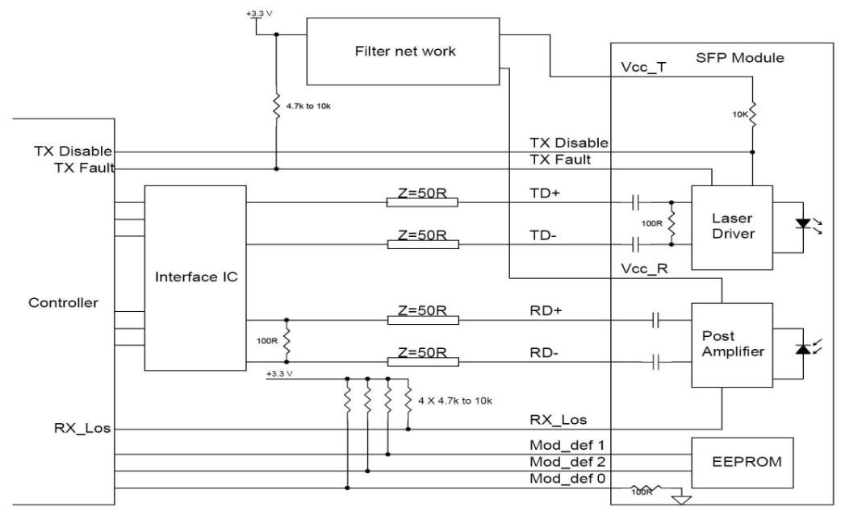
Характеристики электрического интерфейса
Parameter | Symbol | Min | Typ | Max | Unit | Ref.
Supply Voltage | Vcc | 3.15 | 3.3 | 3.6 | V
Supply Current | Icc |  | 185 | 250 | mA
Transmitter
Input differential impedance | Rin |  | 100 |  | Ω | 1
Single ended data input swing | Vin,pp | 250 |  | 1200 | mV
Transmit Disable Voltage | VD | Vcc–1.3 |  | Vcc | V
Transmit Enable Voltage | VEN | Vee |  | Vee+ 0.8 | V | 2
Transmit Disable Assert Time |  |  |  | 10 | us
Receiver
Single ended data output swing | Vout,pp | 250 |  | 800 | mV | 3
Data output rise time | tr |  | 100 | 175 | ps | 4
Data output fall time | tf |  | 100 | 175 | ps | 4
LOS Fault | VLOS fault | Vcc–0.5 |  | VccHOS  T | V | 5
LOS Normal | VLOS norm | Vee |  | Vee+0.5 | V | 5
Power Supply Rejection | PSR | 100 |  |  | mVpp | 6

Функции цифровой диагностики
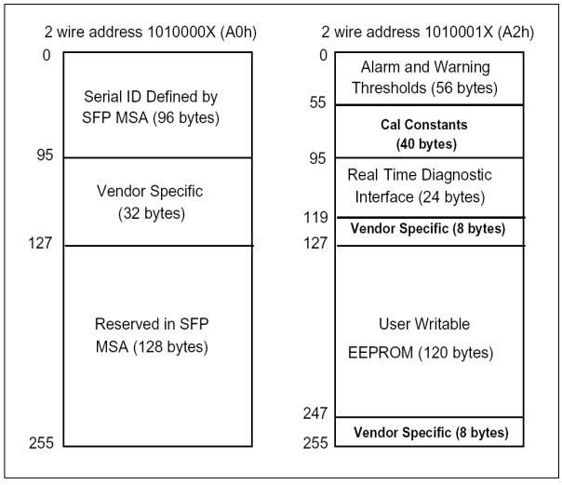
Габариты
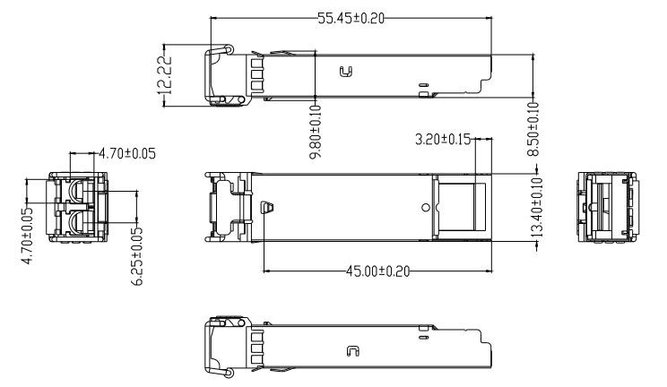
Соответствие нормативным требованиям
Feature | Reference | Performance
Electrostatic discharge（ESD） | IEC/EN 61000-4-2 | Compatible with standards
Electromagnetic Interference (EMI) | FCC Part 15 Class B EN 55022 Class B  (CISPR 22A) | Compatible with standards
Laser Eye Safety | FDA 21CFR 1040.10, 1040.11 IEC/EN  60825-1, 2 | Class 1 laser product
Component Recognition | IEC/EN 60950, UL | Compatible with standards
ROHS | 2002/95/EC | Compatible with standards
EMC | EN61000-3 | Compatible with standards

